CS22120 Software Development Life Cycle
Group 05 Project Plan

Author: All
Config Ref: SE_05_Interaction
Date: Friday 26th October 2012
Version: 1.3
Status: Draft
Table of Contents
1. Introduction 3
1.1. Purpose of this Document 3
1.1.1. Scope 3
1.2. Objectives 3
2. Overview of Proposed System 3
2.1. Technology Being Used 3
2.2. Use-cases 4
2.2.1. Use-case for Users 4
2.2.2. Use-case for Server 5
2.3. User Interface Design 5
2.3.1. User Interface Layout Designs 6
2.3.1.1. Sign Up 6
2.3.1.2. Log In 7
2.3.1.3. Menu Bar 7
2.3.1.4. Cash Pile 8
2.3.1.5. Banner 8
2.3.1.6. Homepage 8
2.3.1.7. Friend's Stable 9
2.3.1.8. Add Friend 10
2.3.1.9. Shop 10
2.3.1.10. Battle Report 11
2.5. Risk Assessment Table 12
2.6. Task Allocation 15
2.7. Gantt Chart 15
3. References 15
4. Document Change History 15

1. Introduction

1.1. Purpose of this Document
The purpose of this document is to describe how we plan on creating the web application from the design to the technology we plan to use.

1.1.1. Scope
This document specifies the user interface designs and what technology will be used.

1.2. Objectives
The main objective of this project plan is to show to the customer how we plan on creating the system. Showing the design of the UI will give the customer an idea of how Monster Mash will look. Describing what technology that will be used will give the customer an insight of the “back end” side of the application.

2. Overview of Proposed System

2.1. Technology Being Used
At first we were thinking of using Tomcat server application, because it supports JSP and Java Servlets and is lighter than every other server application. We decided to use Glassfish, as it is being used by all the other groups and is the only software supported by the university. Glassfish provides full Java EE support including JSP and Java Servlets, which we will be using and is easier to navigate through than alternative software.

Glassfish is an open – source application server by Sun Microsystems. It provides full support for Java EE, JavaBeans, JPA, JSF etc. Glassfish has many more administration and monitoring tools than alternative software, such as Tomcat. We will be using Java Servlets to deal with requests from the client on our server. Considering we are striving for an MVC design pattern, Servlets are the right choice for control i.e handling requests.

A Java Servlet is a Java class used to extend the capabilities of the server. Although Servlets can respond to any types of requests, they are commonly used to extend the applications hosted by web servers, so they can be thought of as Java Applets that run on servers instead of in web browsers.

2.2. Use-cases

2.2.1. Use-case for Users
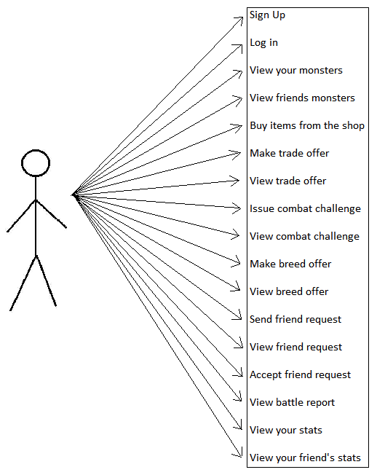

2.2.2. Use-case for Server
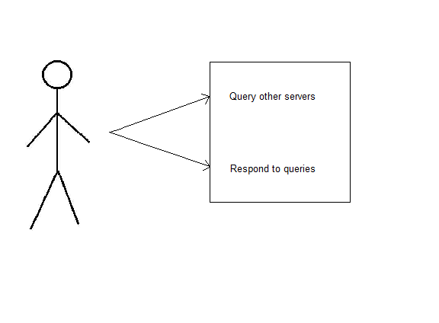

2.3. User Interface Design
To begin the user interface design, we started with a use case diagram which had everything the user needed. From this we created a directed graph which shows all the options the user has for navigation from that page. After agreeing on the pages we will be creating, we started with a basic hand drawn design of what the game will look like. Once we had produced the hand drawn designs, it was necessary to put them in to a digital format as well as annotated versions. There will be seven pages, which include:

- Log In
- Sign Up
- Homepage
- Friend's Stable
- Shop
- Add Friend
- Battle Report

2.3.1. User Interface Layout Designs

2.3.1.1. Sign Up
This will check
the database to see
if the email which has
been entered, is not
already taken.
These fields must match.
This will send the data to the
database and will be the user's
log in credentials. This will direct
the user to the “log in” page.
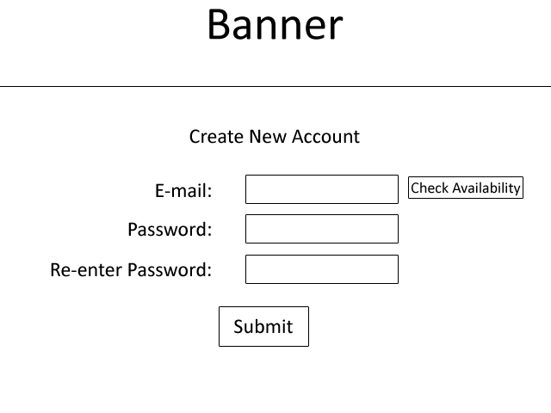

2.3.1.2. Log In
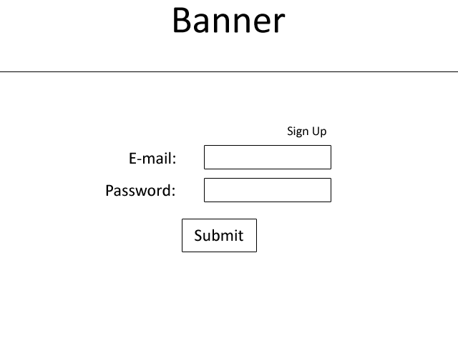
Non-registered user's will
click this to sign up. This will
direct them to the sign up page.
The email and password
that the user entered upon sign
up will be their credentials.
If the user enters the
Correct email and password,
they will be taken to the homepage.
If not, an error message will come
up saying incorrect email/password.

2.3.1.3. Menu Bar
Each page (that the user is signed into (not sign up or log in page)) will have a menu bar. The menu bar will appear below the banner and will be on each page they visit. On this bar, the actions are undecided.

It will have some combination of:
- Home button - navigate the user back to the home.
- Cash Pile – shows the amount of virtual money the user has.
- Friend Request - any requests from people to add/accept.
- Breeding Offers - any offers from friends to breed.
- Sales - any offers from friends to buy (buying a user's monster).
- Shop – buying a starter monster.
Below is an example of the menu bar.

2.3.1.4. Cash Pile
It is one of the requirements for the friends list to be ranked and this can be done by the highest amount of money. Each user will have a database and will be able to be sorted from richest – poorest. This can be added to the homepage once agreed on.

2.3.1.5. Banner
Each page will have a banner which will be a design (text/image) saying 'Monster Mash'. The user will be able to click on the banner and be taken to the homepage.

2.3.1.6. Homepage
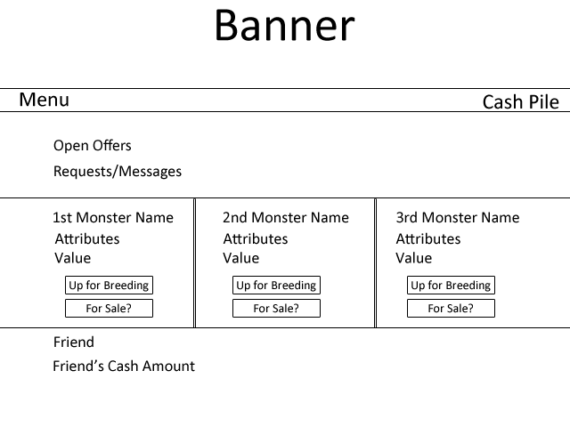
Any open offers the user has such as
friends requests will appear here. From
here, the user can accept/reject the offer.
Messages from other friends will also
appear here.
The user's monsters will appear here and will
have the monster's stats along with value.
It will also show if the monster is up for
sale or breeding. From this, a friend can
visit this stable and accept to breed/buy.
Each friend of the user will
appear here, along with their
cash amount. This would be
in order of the wealthiest.

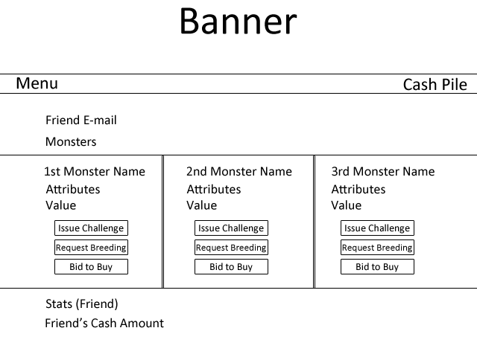
2.3.1.7. Friend's Stable
This is the user's sign up email.
The friend's monsters will appear next to
each other here, and will show the monster
name, attributes, value and give you the option
To challenge them to a battle, request to
breed and put in a bid to buy that monster.
1
3
2

Each player has their own cash pile,
which shows how much virtual
money they have. The friend's amount
of virtual money will appear here.
1. User can challenge this friend's monster
2. User can request to breed with this monster
3. User can put a bid in to buy this monster

2.3.1.8. Add Friend
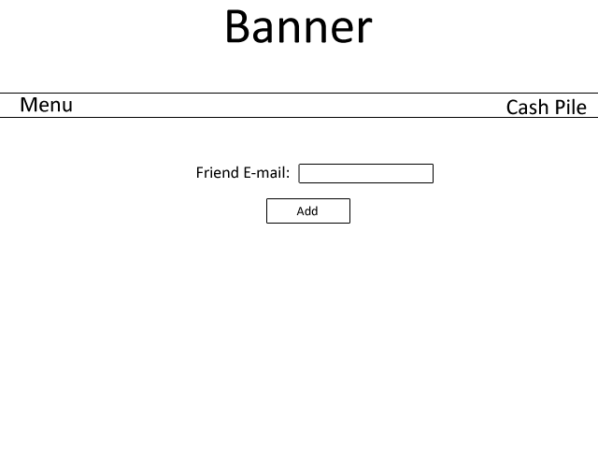
If the e-mail is a valid address,
the friend will be sent a request from
this user and will be seen in the
offers section on the homepage.
If the e-mail is not recognized, an
error message will appear.
The e-mail that the friend used to
sign up will be used for user's
to add them.

2.3.1.9. Shop
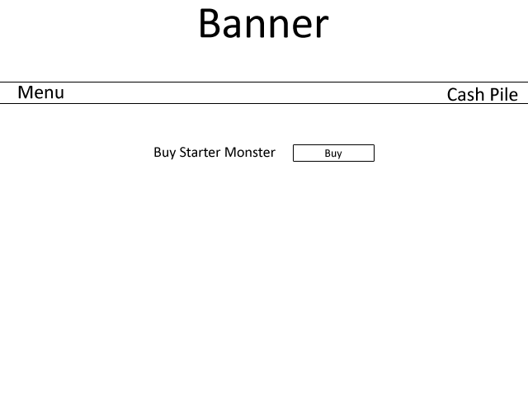
When a user loses all their monsters, they
can buy another monster from this page. After
clicking buy, the money will be deducted from
their cash pile and the monster
will then be their own.

2.3.1.10. Battle Report
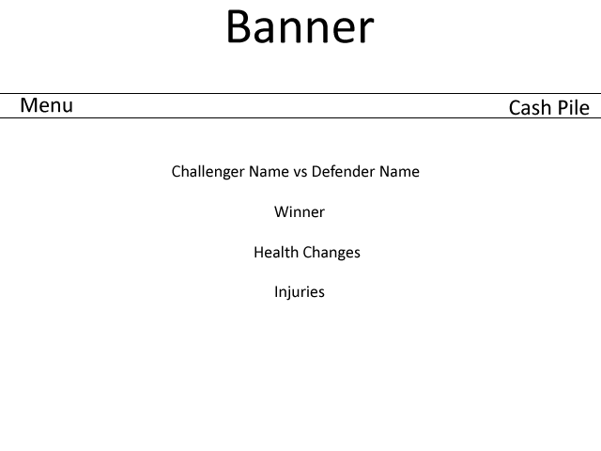
The challenger will be the person that sent the request.
The defender will be the person that accepted it.
The winner of the match will be here.
After each battle, an (not yet specified)
amount will be deducted from
the monster's health. This will show
how much health it has lost and the
monster's current health (including
the deduction).
Any injuries the monster gets will
be stated here. If the monster dies,
an image will appear of a sad monster
with a link to the “shop” page
to buy another monster.

2.5. Risk Assessment Table
Risk | Risk Severity | What Will It Affect? | Measures Put In Place | Other Notes
Illness | Medium-High | Project milestones and group centralisation. | Alert group as soon as possible so group Could act accordingly.
Idleness | High | Group progress towards milestones, project deadlines, loss of motivation. | Project leaders drive group and provide motivation. Make sure there is always a milestone to word towards.
Loss of individual internet connection | Medium | Ability to communicate with group via WebMail and Facebook.  Ability to transmit documents to group.  Ability to gather resources. | Contact numbers distributed to group and meeting at lectures. | Each person has at least another group member in lectures.
Loss of mass internet connection | High | Ability to communicate with group via WebMail and Facebook.  Ability to transmit documents to group.  Ability to gather resources.  Ability to submit work electronically. | Contact numbers distributed to group, arrange project meeting as soon as possible. | Each person has at least another group member in lectures to organise a meetings or use phones to contact.
Flooding | High | Ability for individuals affected to live at house.  Will impede a lot of stress on the individual thus affecting project work motivation and mentality.  Ability to travel depending on severity of flood. | Group supports each other to help through the tough time, offering help where needed. | Depending on severity of flood, level of support /work load will change.
Small coding error and unable to track source of error | Low | Ability to proceed with implementation.  Increased stress to | Use version management to roll back code to last working commit of code.
Deletion of local git repository | Low | Could affect progress of coding/ loss of code. | Commit updates frequently to avoid losing too much code.  Can re-clone online repository to local system.
Deletion of online git repository | Medium-High | Could lose whole project work. | Make sure each group member has an up-to-date local clone of the git repository to re-upload to the online repository/recreate a new one. | To delete the whole online git repository, the version management controller must delete it and manually and confirm deletion by entering the name of the repository to be deleted.
Code incompatibility | Low-High | Interaction of code between group members’ work could be hit and cause program-wide problems. | Make sure coders meet up frequently and work on code together along with QA manager.  Keep all work as centralised as possible by having frequent group meetings in which to do work/assign task at. | If work becomes decentralised, code incompatibility could become a big problem.
Server-server interaction problems | Medium-High | Servers may not be able to communicate with each other. | Make sure frequent meetings between allocated members from other groups are arranged to discuss server-server interaction protocols. | Keep the program as simple as possible but making sure that the program meets all of the requirements.  By keeping it as simple as possible, it is less likely that server-server interaction problems will occur.
Loss of power/crashing of computers | Low-High | Loss of work/ability to work. | Save frequently, commit to git frequently, have a backup plan for do work. | Depending on timeline, this problem could really pressure the group.
Loss of project direction | Medium | Wrong tasks being allocated so wrong work is produced for delivery. | Frequent group meetings, checking requirements specification and appropriate documents to find check if the right goals are being worked towards at the right time.
Individual circumstances | Low-High | Could affect work motivation/priorities as well as group dynamic depending on situation. | Group supports each other appropriately having meetings to decide what to do if needed. Handle delicately. | May not become aware of individual’s circumstances straight away but this is expected.
Browser compatibility | Low | Client requires program to run on all installed browsers in the Delphinium and Solarium. | Keep interface with browser simple and validate to make sure it is compatible.

2.6. Task Allocation
Due to difficulty in presenting the document in a readable state, see the “Project Plan Task Allocation.pdf” document for the task allocation. This will be sent along with the Project Plan and the Gantt Chart.

2.7. Gantt Chart
For the same reasons that the task allocation table cannot be presented as a readable fashion, see the “Project Gantt Chart 27-10-2012.pdf” document for the Gantt Chart. This will be sent along with the Project Plan and the Task Allocation Table.

3. References
N/A

4. Document Change History
Version | CCF No. | Date | Changes made to document | Changed By
1 | N/A | 26/10/12 | This is the first draft | All (each member wrote their part)
1.1 | N/A | 26/10/12 | Table of contents, Introduction and formatting was added. | sjm16
1.2 | N/A | 27/10/12 | Adding of risk assessment table and note of Task Allocation and Gantt Chart will be sent along with this Project Plan. | sjm16
1.3 | N/A | 09/12/12 | Removal of Battle Report Seq. Diagram | sjm16

